**Admin User View : Administrator Activities**

* Create Projects

+ Add/ Edit / Delete Project

* Upload Samples

+ Excel file upload (??)

* Create organisms, locations (??)
* Create user privileges

+ Add/ Edit / Delete privileges

* Create Users

+ User account creation with privileges

+ Assign users for relevant projects

+ Add/ Edit / Delete user details

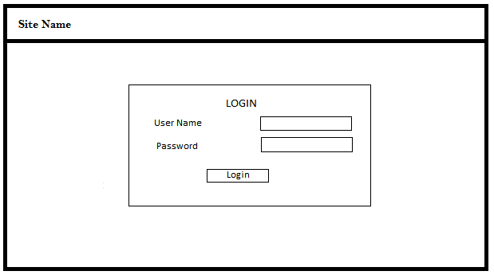**Login**

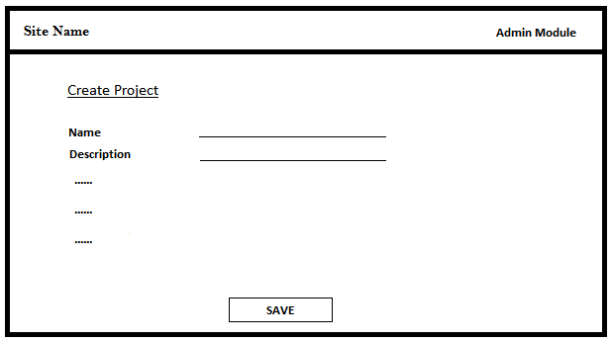**Create Projects**

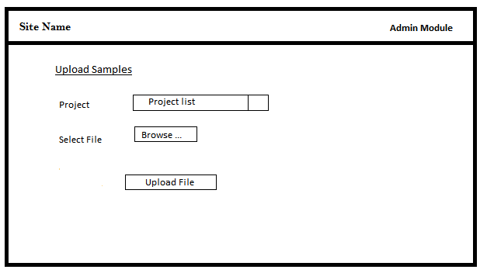**Upload Samples**

**Create Privileges**

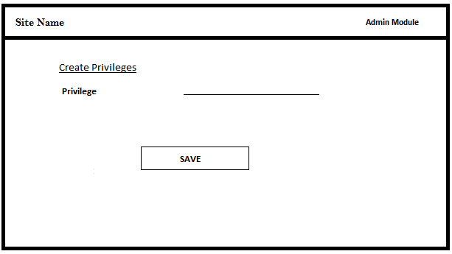

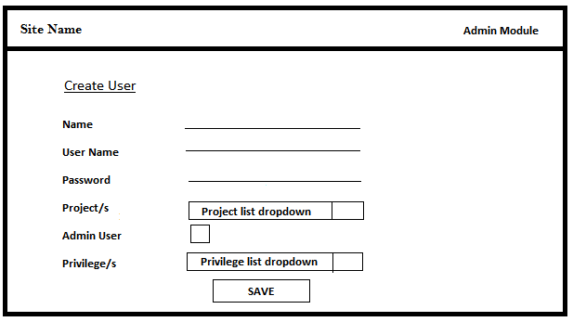**Create Users**

**User View : User Activities**

* Logged in user will only see the projects assigned to him/her.
* When click on the project it will display the list of samples belong to it. (??)
* User activities will be limited depending on the assigned privileges and currently all the users will have privilege to view only.
* User password change option (??)

+ Since the password for the user account is assigned by the admin, better to have an option to change.

* Other functionalities like search, report generation (??)